18 Perfecting the Fight

In a previous tutorial, we created our fight room, and we threw our characters into this room, but are they actually performing in the manner that we would expect them to? They seem to be sizing each other up, and looking at each other menacingly, but when it comes to actually fighting, do we actually have any true interaction between the two. They seem to be fighting each other from across the room, with nothing coming into contact. What, are these two fighting telepathically? The score board progression bar moves, but there is no fight going on. I think this room needs a bit of help, and in this tutorial, we are going to enhance the code so that it gets it.
We are going to create a brand-new object, and we will be calling this new object, obj_hit_effect
These are the 5 code files, that we will be interacting with.
obj_hit_effect
obj_hero_fight_CREATE_EVENT
obj_hero_fight_STEP_EVENT
obj_enemy_fight_CREATE_EVENT_v2
obj_enemy_fight_STEP_EVENT_v2

The Object Hit Effect
The obj_hit_effect will be a brand-new object that we will be creating.
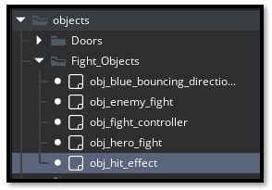
This new object will have 3 Events attached to it.
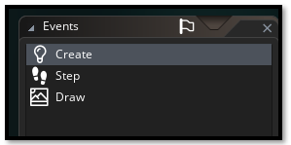
Go here to find the Code for these 3 Events.
obj_hit_effect

The Fight Hero Object
obj_hero_fight
This object already exists we will only be making changes to the code. So, go to this object file in the Fight_Object folder and open it.
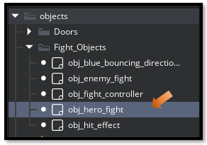
This object will have 3 events attached to it, but we will only be messing with two of them.
CREATE & STEP
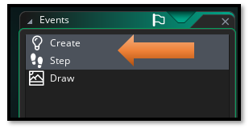

Go here to find the Code for these Events.
2 obj hero fight CREATE & STEP

The Fight Enemy Object
obj_enemy_fight
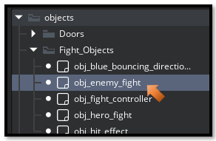

The enemy fight object, also has 3 events attach to it, but again, we will only be messing around with 2 of these events
CREATE & STEP

Fixing Errors
If the two entities seem to be moving through each other, instead of hitting each other and then hitting open air. We will need to adjust the lunge_stop_distance in the obj_hero_fight CREATE event.
